42.54: a) Following the hint,
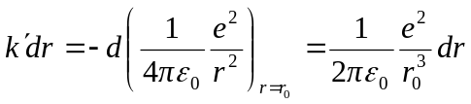
and
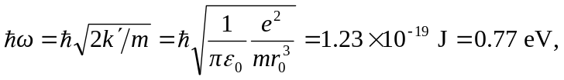
where 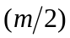has been used for the reduced mass. b) The reduced mass is doubled, and the energy is reduced by a factor of  to 0.54 